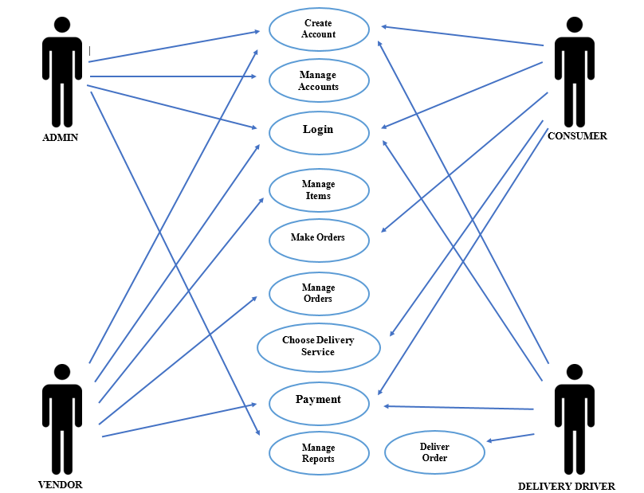E-BUYan: WEB-BASED E-COMMERCE OF TUY PUBLIC MARKET AMIDST COVID-19

This figure shows the 100% range of the system application. This use case diagram shows how the actors interact to each other through the processes of proposed system. First, the admin is the one who will manage all the accounts of consumers, vendors and delivery drivers and also the one who will manage the reports generated in the proposed system. Next, when the vendor is already having an approved account, the vendor can login into the proposed system to manage the items or products that will be posted in the proposed system, afterwards, before a consumer to complete an order, the vendor will have to approve the transaction. And the vendor will notify the costumer for the approval. As for the payment, the vendor will receive payment right after the delivery drivers will pick up the orders of costumer. Then for the costumer, registration of account is required to make an order from the store they want or chose. Then after that the consumer will receive a notification from the vendors that the orders will be processed and ready to deliver. Lastly, the delivery driver will also need to register an account before logging in to the proposed system. Then once the consumer made an order and chose the delivery services, the delivery drivers will purchase first the orders of the consumer to the store then the consumer will pay for the designated amount when the order is delivered.

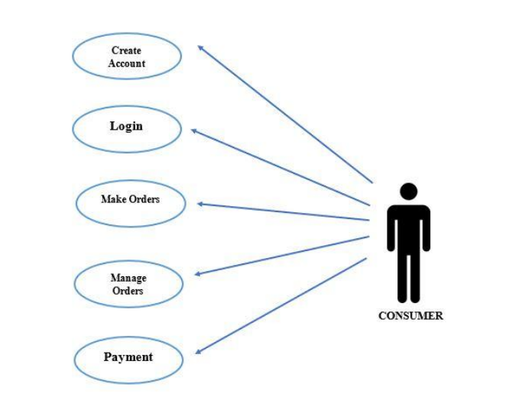This figure shows the 30% range of the system application. This diagram shows how the customer module interact. The first thing that customer will do is to register his/her account then after succeeding the registration, the user will direct to login. Then he /she will be able to make his/her orders. Then after making his/her order, he/she will be able to add and modify his/her order and then he/she can proceed to the transaction or cancel the transaction. If the user proceeds to the transaction, the user will now view the details of the ongoing transaction, status of delivery and amount payable.